CBA Clinic and Show hosted by Harrison High School

Director’s Packet 2017

Welcome to the 2017 CBA Clinic and Show. We will be hosting this inaugural event at both Harrison High School (3 fields) and Mesa Ridge High School (1 Field).

Directions to Harrison High School (ALL OF SHOW PORTION CONDUCTED @ HSS):
For Bands – Take exit 138 (Circle/Lake) from I-25 and go east. Take a right on Janitell Rd. (there will be a McDonald’s and gas station on your far right corner). Follow the road until it comes to a T. Take and follow the road to the school. Buses will park to the right and equipment trucks will park to the left. Booster vehicles will not be allowed to park in this area under any circumstances.

All personal vehicles will be asked to park in the spectator parking lot.
For Spectators/parents – Take exit 138 (Circle/Lake) from I-25 and go east. Take a right into the parking lot for Pikes Peak BOCES, which is across the street from the Circle K gas station.

Directions to Mesa Ridge High School (Pueblo Centennial, East, and South CLINIC ONLY):
Take I-25 north to exit 132 – Mesa Ridge Parkway – and continue east. Take your first left onto Syracuse St. The school will be on your right.

Unit Check-In: Packets can be picked up at check in, which will be at the end of the entrance to the school. Per 2017 CBA policy, anyone entering the field with the band must have either a CBA Director/Staff pass or a performance-specific Field Pass wristband, this includes all pit and prop volunteers. Field Pass wristbands will be used for the Show performances in the evening. The CBA-prescribed number of wristbands (30) will be provided in the Director’s Packet upon check-in. It is the Director’s responsibility to get these wristbands to their volunteers prior to lining up at the field entrance. Additional Field Pass wristbands will NOT be provided. These wristbands grant access to the field only for your band’s performance, wristbands do not provide entrance into the stadium.

Staff Passes: We will honor 2017 CBA passes. We will also accept 2017-2018 CHSAA Passes for School District Staff.

Video: We will record your group’s performance and provide you with an SD card copy. Please be aware this will not be done by a professional company, though we will do everything we can to ensure a quality recording is made.

Clinic – Water jugs will be provided at each clinic site. Please have your students/staff provide their own water bottles for the clinic portion so that they can fill them. Cups and trash cans will not be provided at clinic areas, so please ensure your groups are cleaning up after themselves. There will be power at all clinic sites.

Performance Retreat: Drum Majors will report to the Southwest corner of the track for retreat following the performance portion. There will not be placement trophies given, just participation plaques. If you need to depart early for any reason, please let me know ahead of time and I will have your plaque for you following your clinic portion.

Judges Sheets: Judges’ commentary will be available online. Commentary will be available through DropBox – Please ensure that you have your information to access your account. Only recaps will be put into awards packets, not the individual judging sheets.
Getting on the Field (Performance): Pit and props will get on the field utilizing the outside four lanes of the track (5-8). Bands will load onto the track before the field to allow exiting bands room to leave.

Getting off the Field (Performance): Following the performance, band will exit in the inside lanes (1-4) of the track, exiting out the way they came. Please see the map for flow chart.

Restrooms: Spectator restrooms are located under the press box in the stadium. Additional restrooms are available on the Southeast side of the track. They are located on either side of the brick building.

Band Eating Area: If you would like to feed your band, please utilize ONLY the grass field on the west side of the stadium parking lot. Bands are asked to only setup their food there to avoid congestion in the parking lot. No personal vehicles will be allowed into the area in addition to your one food vehicle, including “just dropping off”, so please plan accordingly.

Admission: CASH ONLY
Clinic portion – FREE!
Performance – Adults: $10 Students/Seniors/Military: $7

Field Amenities: District Two Memorial Stadium has an artificial surface. The field is marked with high school hashes only. Electrical power will be available at the 50 yard line.

Emergency Repair: CIOMIT and Meeker Music will be available with emergency repairs.

The Concession Stand will be open all day, offering a variety of items at very reasonable prices.

If you have any questions or concerns, please contact Keith Bisaillon at any time.

Office: 719-579-2356 Cell: 719-233-4993 E-mail: kbisaillon@hsd2.org
Harrison High School Layout

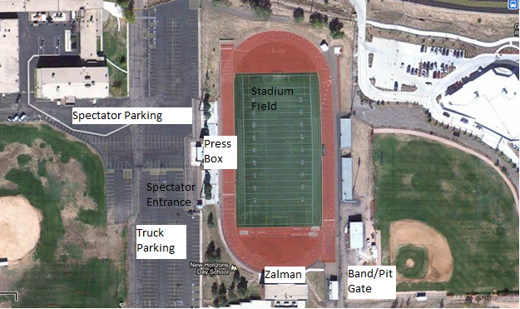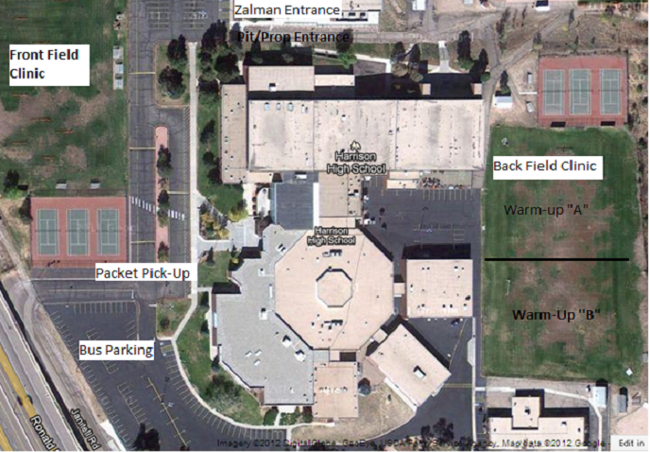

Field Entrance and Exit Flow Map

