8th Annual Legend Marching Festival
Saturday, October 7, 2017
Echo Park Automotive Stadium - Parker
11901 Newlin Gulch Blvd., Parker, CO 80134

Dear Director,

Welcome to the 8th annual Legend Marching Festival. This is the FINAL directors' packet and includes important information including admission prices, concession menu, parking, and a map of the venue. Please review the information carefully and share it with your staff and parent group. This year's event will again be hosted at Echo Park Automotive Stadium (formerly Sports Authority Stadium) in Parker. Directions to the stadium can be found in the packet. Please be aware that this is NOT Sports Authority Field at Mile High, and NOT at Legend High School.

Our philosophy is to provide a positive educational experience for 1a/2a/3a bands and 4a/5a bands that did not make semi-finals or higher in the previous year's CBA Championships. We sincerely hope you enjoy the festival and find it a valuable part of your marching season. Bands were scheduled based on past Legend Fest Participation / Legend Fest Placements last year / CBA Placements last year and Time Stamp of receiving information. If you have any conflict which will prevent you from performing in Finals competition, please contact Orlando Otis immediately.

We will have a clinician meet with each band directly after their performance. We will have many volunteers on hand at the event, wearing blue Legend shirts, to answer questions and help make the event run smoothly. Thank you again for your participation. Should you have any questions or concerns, please feel free to contact me or one of our coordinators.

Sincerely,

Orlando Otis Gilbert “Bear” Gamard
Director of Bands/Performing Arts Dept. Chair Legend H.S. Band Booster President
Legend High School 720-879-1746
303-387-4610 band office ggamard@gmail.com
olotis@dcsdk12.org

Mike Constance Laurie Roach
Festival Coordinator Festival Co-Coordinator
720-988-8683 303-827-9750
legendmarchingfest@gmail.com legendmarchingfest@gmail.com

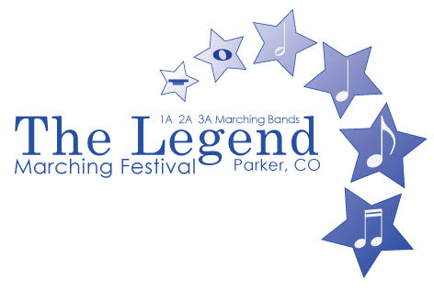
__________________________________________________________
Legend High School Band Boosters, PO Box 3393, Parker CO 80134
www.legendtitanband.com

FINAL Director’s Packet 2017

Directions to Echo Park Automotive Stadium (formerly Sports Authority Stadium):
From I-25 – Take exit 192, Ridge Gate Parkway.
East on Ridge Gate Parkway 3 miles to Chambers Road. Turn right (south) on Chambers Road about 1 mile to Double Angel Road.
Buses/equipment trucks turn right on Double Angel Road.
Buses turn Left into the lower parking lot. Equipment trucks continue on Double Angel Road and turn Right at the SECOND entrance to Double Angel.
Spectators and Food Trucks continue on Chambers Road for an additional 1/4 mile to Newlin Gulch Blvd. Turn right at the signal light and continue to parking lot entrance.

From Parker Road/CO Hwy 83.
West on Hess Road 2 miles to Chambers Road.
Turn right (north) on Chambers road about 1 mile to Newlin Gulch Blvd.
Spectators and Food Trucks turn left on Newlin Gulch Blvd. (at signal light) and continue to parking lot entrance.
Buses/equipment trucks continue on Chambers Road for an additional 1/4 mile to Double Angel Road and turn left.
Buses turn Left into the lower parking lot. Equipment trucks continue on Double Angel Road and turn Right at the SECOND entrance to Double Angel.

All personal vehicles will be asked to park in the spectator parking lot. Food vehicles/trailers will need to park in the upper stadium parking lot near the stadium entrance. There will be volunteers directing food vehicles to their assigned parking. There will be no food/food distribution allowed in the bus and/or pit truck areas.

Check-In: Located upon entry along Double Angel Road. You will receive your Director’s packet with final details and wristbands when you arrive. Students’ hands will be stamped upon arrival. This stamp will allow students access to the festival before and after their performance. Bus drivers will also receive a hand stamp. You will receive 1 wristband for every 10 students, use them as you wish.

Field Pass Wristbands: Per 2017 CBA policy, anyone entering the field with the band must have either a CBA Director/Staff pass or a performance-specific Field Pass wristband, this includes all pit and prop volunteers. Separate Field Pass wristbands will be used for prelims and finals performances. The CBA-prescribed number of wristbands (30) will be provided in the Director’s Packet upon check-in. It is the Director’s responsibility to get these wristbands to their volunteers prior to lining up at the field entrance. Additional Field Pass wristbands will NOT be provided. These wristbands grant access to the field only for your band’s performance, wristbands do not provide entrance into the stadium.

Staff Passes: We will honor 2017 CBA passes and CHSAA administration passes.

Director’s Hospitality Room: We will have a Directors/Staff Only Hospitality Room, located in the home locker room at the north end of the stadium, which we host for directors to drink coffee, eat a little, and sit and chat when you need that escape. Open from 8:00 am – 4:00 pm.

Band Staging and Flow: No playing is allowed except in the Music Warm-Up Area. Do not use taps when approaching the performance field. NO AMPLIFIED METRONOMES OR GOCK BLOCKS MAY BE USED IN ANY WARM-UP AREA.
- Warm-Up Schedule – Attached is a warm-up schedule indicating the area you will warm up in and the times you will warm up. Please follow this schedule and know your times. We will provide an escort for each band. Your escort will meet you near your instrument trucks approximately 10 minutes before warm-ups begin.
- Pit Warm-Up Area – This area is located at the north-east corner of the Double Angel parking lot. Please make sure your Pit Instructor knows they are responsible for maintaining the schedule. NO DRUM LINES WILL BE ALLOWED TO WARM UP WITH THE PIT IN THE PIT WARM UP AREA.
- Drum Line Warm-Up Area – The drum line warm up area will be behind the dugouts, not on the fields. Please see the facility map.
- Color Guard Warm-Up Area – The color guard warm-up area is in the north-west corner of the Double Angel parking lot. Please see the facility map. It is a shared area with no assigned times or designated places. No sticks or gock blocks may be used in this area – this is a quiet zone. Hand claps only.
- Body Warm Up – There are two body warm-up areas indicated on the map as A and B. You will have 30 minutes to use this space before moving to the music warm-up area.
- Music Warm Up - There are two music warm-up areas indicated on the map as A and B. You will have 30 minutes to use this space before moving to the competition entry gate at the northwest corner of the stadium.
- Stands – Only Staff will be allowed into the stands to watch the performance. Parents and volunteers MUST STAY ON THE TRACK for your band’s performance.

Water: Water will be provided for performing students at the competition entry gate. Bands may refill their water jugs in Director’s Hospitality.

Field Amenities: The Echo Park Automotive Stadium (formerly Sports Authority Stadium) has an artificial turf surface. The Field is marked with high school hashes only. Electrical power will be available on the front side at the 50-yd line. Please make sure that you are familiar with the CBA Rules, which outline power outages on the field, caused by band's front ensembles.

Clinicians: A 10-minute performance workshop will be provided immediately after your preliminary performance by one of two clinicians.

Prelims Retreat: Drum Majors only will report to northeast sideline for retreats. The Prelims Retreat will be following Legend’s Exhibition performance. Drum Majors should meet at the Competition Exit gate at 4:30 pm. Due to the fast turnaround between the Prelim Drum Major Retreat and the first Body Warm-up time for Finals, the Chief Judge will notify, by cell phone, the first 4 bands that will be performing in the Finals as soon as the results are determined. 13 bands will participate in finals. At least two bands from each of the 2A & 3A bands will perform in the Finals. The remaining slots will be filled by the top scoring bands regardless of division.

Video Recordings: Band directors will receive video recordings on DVD of their band's prelim performance. Mark Flick will be providing these DVDs and the cost was included in your registration fee.

Judge Comments: Your judges' comments will be sent to your Dropbox account.

Medical: Directors are responsible for medical issues involving their students and staff in accordance with their respective district/school policies. No medical staff will be on hand at the festival. In the event of a medical emergency, please call 911 then alert the volunteer staff. We do have directions to the closest hospitals at the ticket booth if needed.

Commemorative Items: This year we will have event patches available for sale. A festival patch is $4.00. A rocker bar with the year is an additional $1.00. We will also be selling programs for $2.00 and event t-shirts for $15.00.

Restrooms: Restrooms are located near the concession stand. Additional restrooms are available on the northwest side of the stadium. Use the band competition entry gate for access. As this is the same gate as bands entering the competition field, we ask that only small groups enter at a time – this is a QUIET ZONE. Please do not use this area to view the competition. Porta-potties are available in the band warm-up area.

Emergency Instrument Repair: CIOMIT will have an instrument repair technician on site during the day outside the competition entry gate in the northwest corner of the stadium.

Trash: You will be responsible for cleaning any area you use during the festival. Please make sure that any trash is thrown into the dumpsters in the northwest corner of the stadium. Do not leave bags of trash anywhere on the festival grounds when you depart.

Security: Each director will be responsible for the safety and security of their students, equipment, equipment trucks, buses and any other item associated with their program. The marching festival is not responsible for theft or damage. Keep all vehicles locked and monitored.

Finals Retreat: Drum Majors only will report to northeast sideline for retreats. Drum Majors should meet at the Competition Exit gate at 9:30pm.

Spectator Parking: Included is the facility map. Please email this to your parents or post on your website so spectators are aware of the parking for this event. Ample handicap parking is available immediately in front of the press box.

Concessions: The concession stand will be open all day and is located in the southeast corner of the stadium. The price list is included in this packet. Concessions are cash only

Admission: Cash, MasterCard, Visa
 | Adults | Seniors/Students
All day pass | $20.00 | $12.00
Prelims | $12.00 | $7.00
Finals | $12.00 | $7.00
Children under 5 admitted free

Students may be required to show ID for discounted admission

Uniformed Military with valid I.D. admitted Free

Pit/Prop volunteers will be admitted to the field only. No one will be admitted to the stands without an admission wristband or participant hand stamp.

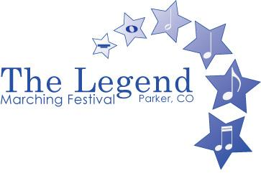

Judges for this year’s event:
Chief Judge | Jack Yonce |  | Announcer | Mike Nolan
Judge | Rich Zamperini |  | Clinician | Jair Klarfeld
Judge | Ed Cannava |  | Clinician | Kate Margrave
Judge | Steve Martin
Judge | Louie Lugo
Judge | Ward Durrett
Judge | Bruce Jones
Judge | Charles Craig
Judge | Mike O’Neil
Judge | Shirl Chumley

Preliminaries Schedule
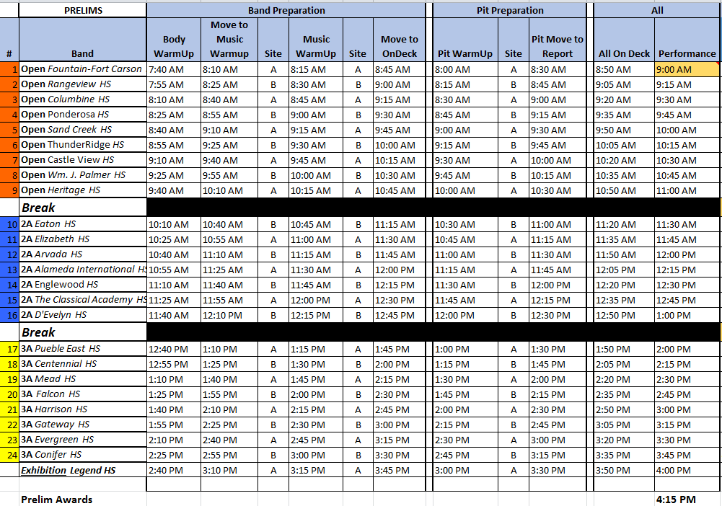
Finals Schedule

Event Map

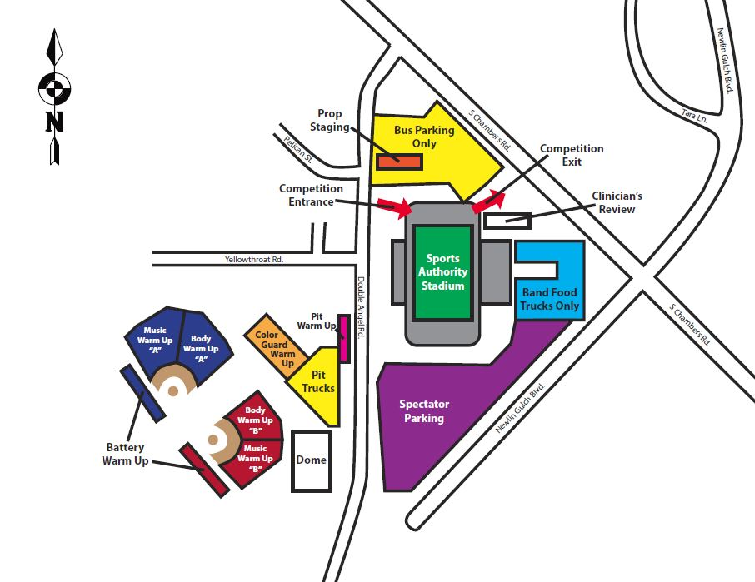

LHS BAND CONCESSIONS MENU:

Breakfast Menu:
Breakfast Burrito |  | $4.50
*Eggs, Potatoes, Cheese
*Sausage, Eggs, Potatoes, Cheese
Cinnamon Sugar Pretzel |  | $3.50
Pastries |  | $2.00
Mini Donut Pack |  | $1.00
Meal Choices:
Hot Dogs |  | $3.00
Chili Cheese Dog |  | $4.00
Frito Pie  (Chili Con Carne w/Beans, Cheese, Sour Cream, Jalapenos) |  | $4.00
Hamburger |  | $4.00
Cheeseburger |  | $4.25
Snacks:
Pretzels (salted or cinnamon sugar) |  | $3.50
Nachos w/cheese |  | $3.00
Candy |  | $1.00
Sour Patch and Super Ropes |  | $2.00
Popcorn |  | $2.00
Cotton Candy |  | $3.00
Extra Cheese or Chili Cup |  | $1.00
20 oz. Bottled Beverages: |  | $2.00
Pepsi | Gatorade
Diet Pepsi | Lemonade
Sierra Mist | Rootbear
Dr. Pepper | Tea
Mountain Dew | Water
Hot Beverages: |  | $2.00
Hot Cocoa & Mocha
Coffee & Tea

